Date of planning: …/… / 2023
Date of teaching: …/… / 2023
Week: UNIT 9: FESTIVALS AROUND THE WORLD
Period: Lesson 1: Getting started – A Tulip Festival
I. Objectives
By the end of this lesson, Ss will be able to gain:
1. Knowledge
- An overview about the topic “Festivals around the world”
- lexical items related to the topic “Festivals”: names of different festivals around the world
2. Core competence
- Develop communication skills and cultural awareness
- Be collaborative and supportive in pair work and teamwork
- Actively join in class activities
3. Personal qualities
- To teach Ss to work hard and love festivals around the world. the responsibility for community to protect our country’s Festivals.
- Develop self-study skills
II. Materials
- Grade 7 textbook, Unit 9, Getting started
- Computer connected to the internet
- Projector/ TV/ pictures and cards
- sachmem.vn
III. PROCEDURES :
Activity 1: Warm-up (5’)
* Aim: To introduce and lead in the topic of the unit.
* Content: Chatting – Answer some questions.
* Products: Ss look at the picture and answer the questions.
* Organization of implementation:
Teacher’s and Ss’activities |  |  | Content
* Teacher shows the picture of the Tulip Festival and asks students some related questions:  ** Students raise hands to answer the questions.  *** Teacher and students discuss the questions.  **** Teacher accepts all students’ questions. |  |  | Chatting:  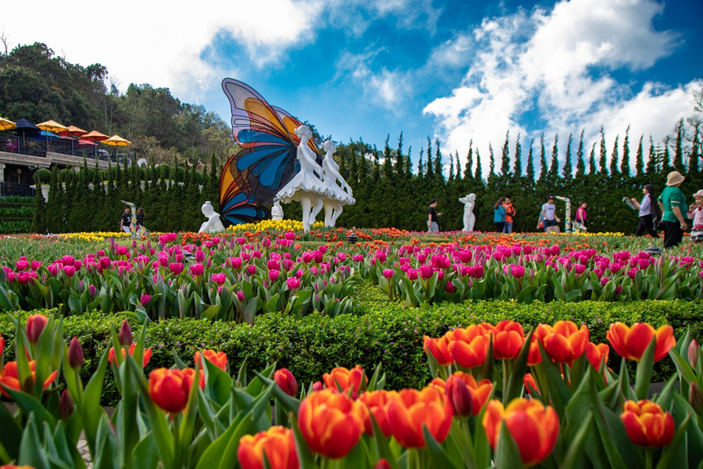  - What can you see in the picture?  - Can you guess the name of the festival?  - Have you ever heard of this festival? If yes, what do you know about it?
Activity 2: Presentation (5’)
(Pre-teach vocabulary)
* Aim: - To provide students with vocabulary.
- To help students well-prepared for the listening and reading tasks.
* Content: learn some vocabularies related to the topic.
* Products: Students read and understand the meaning of vocab.
* Organization of implementation:
Teacher’s and Ss’activities |  | Content
* Teacher introduces the vocabulary by giving definitions/ examples/ pictures of the words.  ** Teacher writes all students’ answers on the board.  *** Teacher circles or highlights the following words and discuss the meanings of these words:  **** Teacher checks students’ pronunciation and gives feedback. Teacher reveals that these words will appear in the reading text and asks students to open their textbook to discover further. |  | * Vocabulary  1. folk dance (n)  2. costume (n)  3. float (n)  4. parade (n)  5. feast (n)  6. fireworks display (n)
Activity 3: Practice
Task 1
* Aims: -To have students get to know the topic.
* Content: Listen and read the conversation.
* Products: Students read and understand the meaning of the conversation
Students know how to role play.
* Organization of implementation:
Teacher’s and Ss’activities |  | Content
* Teacher can play the recording more than once.  ** Students listen and read.  *** Teacher invites some pairs of students to read aloud.  **** Teacher checks students’ pronunciation and gives feedback. |  | Task 1: Listen and read (p.92).  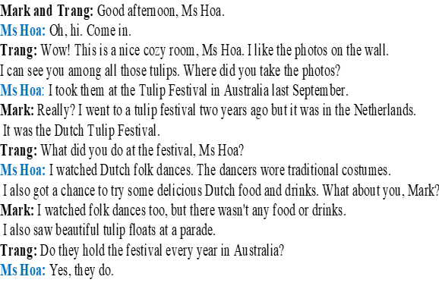
Task 2
* Aims: To have students get specific information of the text.
* Content: Read the activities and tick the correct column.
* Products: Students give the answers exactly.
* Organization of implementation:
Teacher’s and Ss’activities | Content
* Teacher tells students to read the conversation again and work independently to find the answers.  ** Students do the task individually.  *** Teacher allows students to share their answers before discussing as a class and encourages them to give evidence.  **** Teacher calls some students to give the answers and gives feedback. | Task 2: Read the conversation again. Who did the following activities? Tick the correct column. Sometimes you need to tick both  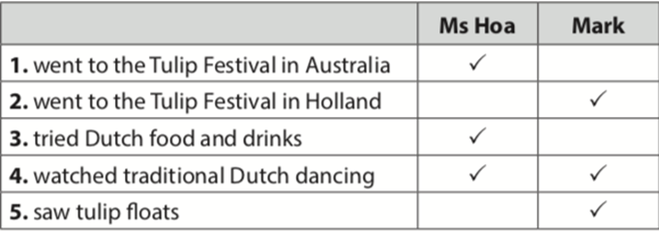
Task 3
* Aims: To introduce some more vocabulary related to the topic festivals.
* Content: Write a word or phrase from the box under each picture
* Products: Students say aloud the names of the cities and provide more information about them
* Organization of implementation:
Teacher’s and Ss’activities | Content
* Ask Ss to look at the pictures and say what they can see.  ** Have Ss work individually to match the words / phrases in the box with the pictures. *** Have them compare their answers with a partner. Ask for Ss' answers.  **** Confirm the correct answers.  - Have some Ss practise saying the words / phrases. | Task 3: Write a word or phrase from the box under each picture (p.93).  * Answer key:  1. parade  2. costumes  3. feast  4. float  5. fireworks display  6. folk dance
Task 4
* Aims: -To help Ss practise the words/phrases in 3.
* Content: Students fill in the blanks with the most suitable form of word/phrase.
* Products: Ss play in group actively and give the answers corectly.
* Organization of implementation:
Teacher’s and Ss’activities | Content
* Teacher asks students to complete the task by playing game “LN”  - Teacher divides the class into 2 groups.  ** Teacher asks students to choose the number and answer the questions quickly in 5 seconds.  - If students choose the lucky number, they don’t have to answer  - If students choose the Q , they have to answer exactly and will get 2 points.  ***Students fill in the blanks with the most suitable form of word/phrase.  ****The group has more points is the winner. | Task 4: Fill in each blank with a word or phrase from 3. You may have to change the form of the word or phrase (p.93).  Game: Lucky Numbers  * Answer key:  1. folk dances  2. fireworks display  3. feast  4. parades  5. floats; costumes
Activity 4: Production (5’)
Task 5
* Aims: To check Ss’ knowledge of some familiar festivals.
* Content: Match each description with a festival
* Products: Ss give the answers corectly.
* Organization of implementation:
Teacher’s and Ss’activities | Content
* Teacher lets Ss work in groups of 4-6.  ** Ss work in groups to find the answers.  *** Teacher can go around to help weaker students.  **** Teacher calls the first group to come up with the answers to share. | Task 5: Quiz. What festival is it? Match each description with a festival (p.93).  * Answer key:  1. e  2. a  3. d  4. c  5. b
Activity 5: Consolidation (3’)
* Aim: To consolidate what students have learnt in the lesson.
* Content:. Vocab about school things and Read and understand content of the conversation
* Products: Say aloud some words they remember from the lesson.
* Organization of implementation:
Teacher’s and Ss’activities | Content
Teacher asks students to talk about what they have learnt in the lesson. | - some new words  - Read and understand content of the conversation
* Homework (2’)
* Aim: To review the lesson and prepare for the next lesson.
* Content: Review the lesson and prepare for the next lesson and do exersie in the workbbook
* Products: Students’ textbooks and workbooks
* Organization of implementation:
Teacher’s and Ss’ activities | Content
- T reminds Ss to do homework and prepare the new lesson. | - Learn by heart all the new words.  - Name at least 3 festivals around the world.  - Prepare lesson 2 ( A closer look 1).
* Evaluation: …………………………………………………………………………………………………………………………………………………………………………………

